# Requirements Elicitation

## Functional Requirements

The system should support two primary user roles: the Customer and the Bank teller. Each has distinct responsibilities.

**Customer Functions:**

1. **Login:**  Customers should log in using credentials linked to their account before performing any transactions.
2. **Make Deposit:** Logged-in customers can deposit funds into any of their accounts in the bank.
3. **Make Withdrawal:** Logged-in customers can withdraw funds from either their Cheque or Investment account. Funds cannot be withdrawn from Savings accounts.
4. **View Transaction History:** Logged-in customers can view all the transactions for any of their accounts in the bank. This includes deposits, withdrawals, and interest credits.

**Bank Teller Functions:**

1. **Open Account:** Only bank tellers can open new accounts. During this process:

* Customer details are captured.
* For Savings accounts, tellers should specify if the customer is an Individual or a Company. This is to determine the interest rates.
* For Cheque accounts, tellers should obtain the employer information (company name, address, etc.) of the customer who is opening the account. If the customer is self-employed, the business name is recorded as the employer.
* For Investment accounts, tellers make sure that a minimum deposit of BWP 500.00 is met.

**System-Automated Function:**

1. **Pay Monthly Interest:** Occurs every month. Fully automated. Calculates interest polymorphically based on the account type and customer type (for savings), credits the amounts to the accounts and logs it in the transaction history and “Interest Credited.”

**Appendix: Interview Record**

* **Interviewer:** Olerato Leburu
* **Interviewee:** Kentsenao Baseki
* **Date:** 18/09/2025
* **Time:** 10:30 - 12:16
* **Place:** Virtual meeting via Microsoft Teams

**Interview Questions and Answers:**

Q: What are the rates of savings accounts?

A: The company rate is 0.075, while the individual rate is 0.025.

Q: Should monthly interests require authorisation or be fully automated?

A: They should be fully automated.

Q: Should monthly interests be shown in the transaction history?

A: Yes. The value should be shown as interest credited to the account.

Q: Should a system that can handle incorrect login attempts be implemented, e.g. account logs out after 3 incorrect attempts?

A: Not yet. The feature is not required at this stage. It may be focused on at a later stage.

Q: Should the system output reports such as the number of customers, total accounts open, etc, on request?

A: No. That is not required.

Q: If a customer is self-employed, how would they register for a cheque account?

A: Their 'employer' would be their source of income, e.g. if they have a small shop, their revenue would be their income, and their 'employer' would be the small shop.

## Non-Functional Requirements

1. **Security**

* Customers must log in to access their accounts. Basic authentication is required (e.g. account number and PIN).
* Although lockout after failed attempts is to be developed at a later stage, the system should still validate the credentials provided securely.

1. **Usability**

* Two distinct interfaces: one for customers (post login dashboard) and one for the bank teller (account opening, transaction assist).
* Clear navigation and error messages (e.g. “Withdrawal not allowed from savings account”).

1. **Maintainability**

* Core logic is implemented using OOP principles to allow for easy extension, such as adding new account types.

1. **Reliability**

* Transactions must be synchronised. The balance updates and transaction logs must succeed or fail together.
* Interest calculations should be accurate and consistent.

1. **Performance**

* Login and transaction operations must complete within a small amount of time (e.g. 2 seconds) under normal load.

# Structural UML Modelling

**Use Case Diagram**

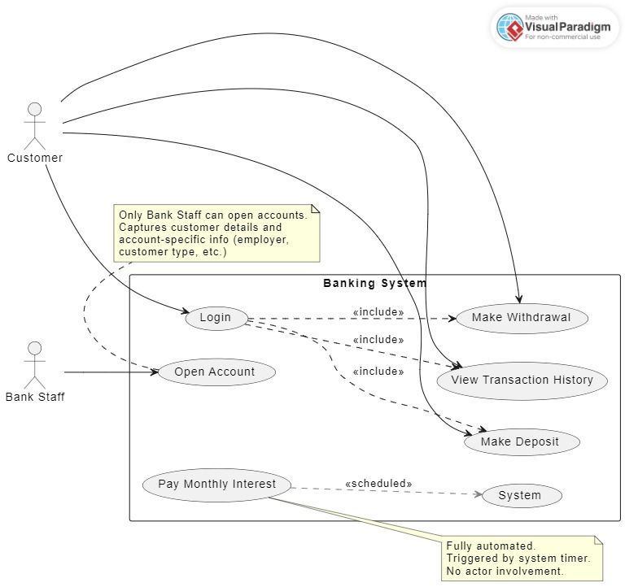

**Class Diagram**

# Behavioural UML Modelling

**Sequence Diagram 1: Customer Login and Make Deposit**

**Sequence Diagram 2: Bank Staff Opens Cheque Account**

**State Diagram:**

**Class:** Transaction

